Reading: Section 5
Chapters 87 - 109

Overview
The temptation to go online and look up explanations or summaries of the novel is difficult to resist. However, trust yourself. Your impressions are all that matter for this first reading. When you have finished, then if you wish, read what others think. But not now. Meet Melville one on one.
Melville has established his conflicts and themes. Ishmael has become transcendental in his descriptions.
Continue to note how the literal is a springboard to the abstract or elevated. Be Ishmael. See behind the mask.

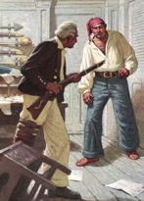
Starbuck & Ahab
You hopefully are into the drama or lack thereof. Continue to gain insight into the characters and personalities of both Ahab and Starbuck.
The following questions ask you to compare/contrast Ahab and Starbuck as antagonists. Answer them as you can, or skip them for now.

- How do Ahab and Starbuck differ in their moralities and philosophies of life?
- Is Ahab or Starbuck the stronger of the two?
- How do you account for that? What does one have that the other lacks?

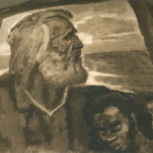
Ahab & Pip
In this section Little Pip crosses the line into irrationality, and Ahab becomes his protector.
Dive deep: Why?

