Reading: Section 3
Chapters 43-65

Overview
When you finish section 3, you are half way through your journey. Are you a survivor, or will you jump ship? Chop wood. Carry water.
Pause here to think about Melville's style. He uses a variety of stylistic and structural techniques. Do you notice a similarity between some chapters of Moby and Shakespeare's style?

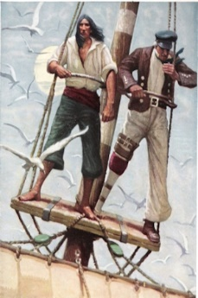
Characters
- Continue keeping notes on, especially, Ahab and Starbuck. Stubb's character/personality is also more fully shown in this section.
- Chapter 46, Surmises, gives deeper insight into Ahab's character and into his thinking processes. Note Ahab's acknowledgement that he has, indeed, overstepped the boundaries of even a captain. What does he know the crew can legally do about the hunt for Moby if he does not take care to prevent it? What does he intend to do?
- Recall that Starbuck is the only crew member to object to Ahab's hunt for Moby. Be aware also, that Starbuck, as chief mate, has the right and responsibility to take command of the ship if the captain becomes incapacitated (physically or mentally) or derelict in his duties. One of Ahab's principal duties is to collect whale oil to sell. In this section does Starbuck consider any plans to remove Ahab from command?
- Describe the mysterious voices and the dusky phantoms (Chapters 46 and 50) that are seen around Ahab. Who are they? What seems to be their purpose on the ship? As you proceed, consider what purpose they serve in the novel. Why did Melville include them?
- Take note of Ishmael's observation of concrete objects or sightings and his elevation of them. He will increasingly elevate concrete scenes and events. For instance, Ch. 51, The Spririt-Spout, describes a real sighting that is associated with Moby Dick, then associates it with the mysteriousness of Life. In Brit, Ch. 58, he realistically describes a peaceful scene of Right Whales scooping up Brit, then elevates that scene to the "full awfulness of the sea."
Remember, Ishmael is a Romantic, a symbolist. He is no longer a landsman, who concentrates only on the "real." Reality for a Romantic is but a mask or symbol of what lies beyond. For example, the surface of the sea itself is a "reality"; what lies hidden beneath is "truth." Reality is paradoxical.
- During this section, you will have the first gam. The Town-Ho's story may be somewhat foreshadowing, but do not get too involved with it. Read it and move on. Keep moving. Chop Wood. Carry Water.
Know what a gam is and take note of how the other ships compare or contrast with the Pequod. As you have other gams later, Ahab's personality will change.

